**Two Point Source Interference Patterns**

When two speakers play a single sustained note in phase, a distinct interference pattern emerges.

In front of the speakers, there will be alternating bands of loudness (from constructive interference) and softness (from destructive interference).

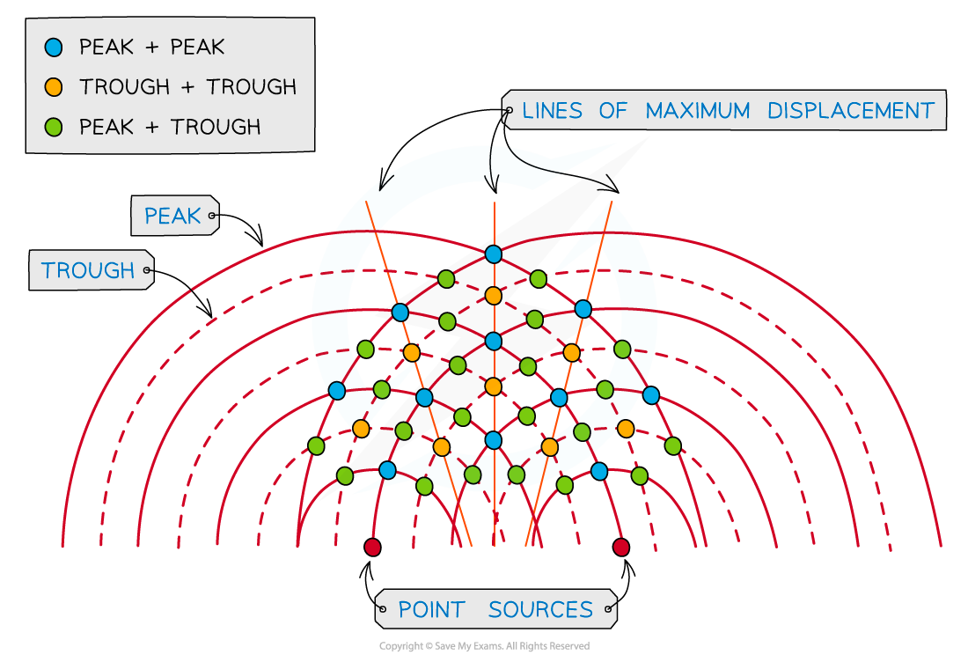

The **path difference** at any given point is the difference in the distance travelled by the two waves. It is usually expressed in terms of the number of wavelengths travelled.

If the waves are in phase at the time they leave the speaker, they will be **in phase**at any point where their **path difference** is **a whole number of wavelengths** (e.g. *λ*, 4*λ*, 183*λ*).

*Path difference at Point C = 2*λ*; waves will be in phase (i.e. constructive interference)*

If the waves are in phase at the time they leave the speaker, they will be **out of phase**where the **path difference** is **a whole number of wavelengths plus half a wavelength** (e.g. 0.5*λ*, 1.5*λ*, 9.5*λ*, 123.5*λ*).

*Path difference at Point D = 0.5*λ*; waves will be out of phase (i.e. destructive interference)*

**Questions**

1. A and B are two identical wave sources in a ripple tank vibrating in phase. The wavelength of each wave is 3 cm. For each of the following cases state whether there will be constructive or destructive interference at point X.











1. A and B are identical sources in a ripple tank vibrating in phase.



* 1. Calculate three different wavelengths for which the point X would permanently show:
     1. zero displacement
     2. maximum displacement.
  2. The water waves travel at 0.36 m s-1. What is the lowest frequency of a source that produces destructive interference?

1. Alan placed two speakers 12.0 m apart and facing one another. He connected them both to a sound generator, set it to 86.5 Hz, and turned it on. Then he walked at a steady speed of 0.800 m s-1 in a straight line from one speaker to the other. Calculate how many quiet locations he walked through, and hence calculate the time it took for Alan to walk from one loud region to the next. Take the speed of sound in air to be 346 m s-1.

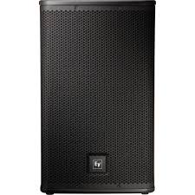

12.0 m

**Challenge Questions**

Go to <https://www.falstad.com/ripple/>. Select ‘Example: Two Sources’ and ‘Color Scheme 2’.

1. Observe what happens to the number of bands of destructive interference as you increase the Source Frequency. Why might this be occurring?
2. Set the Source Frequency back to 4 and move one of the sources by clicking and dragging it. Click ‘Clear Waves’ once you have finished moving it. Observe what happens to the number of bands of destructive interference as you change the distance between the two sources. Why might this be occurring?